Vendor Payment Analytics

A PROJECT REPORT

Submitted by

Himanshu Fulera(12304291)
Ayush Yadav(12310208)

in partial fulfillment for the award of the degree
of
Bachelor of Technology
IN
COMPUTER SCIENCE



Lovely Professional University, Punjab

Lovely Professional University, Punjab

BONAFIDE CERTIFICATE

Certified that this project report “Vendor Payment Analytics” is the bona fide work of “Himanshu Fulera, Ayush Yadav” who carried out the project work under our supervision.

Department of Machine Learning, CSE,
Lovely Professional University, Punjab

Himanshu Fulera, Ayush Yadav
SIGNATURE

<<Signature of the Head of the Department>>
SIGNATURE
<<Name>>
HEAD OF THE DEPARTMENT

<<Signature of the Supervisor>>
SIGNATURE
<<Name of the Supervisor>>
SUPERVISOR

APPENDIX III
TABLE OF CONTENTS

CHAPTER NO. | CHAPTER NAME | PAGE NO.
 | Title Page | 1
 | Bonafide Certificate | 2
 | Table of Contents | 3
 | Abstract | 4
I. | Introduction of the Project | 4
A. | Problem Description | 4
B. | Objectives | 4-5
II. | Related Work/Literature Review | 5
III. | Proposed Methodology | 5-6
IV. | Implementation Plan | 6-7
V. | RESULTS AND DISCUSSIONS | 7-8
VI. | Conclusion | 8
 | References | 8-9

Vendor Payment Analytics

Himanshu Fulera
Computer Science and Engineering
Lovely Professional University
Punjab, India
hkhimanshu3214@gmail.com
Ayush Yadav
Computer Science and Engineering
Lovely Professional University
Punjab, India
ayushyadav@gmail.com

Abstract— Timely management of vendor payments is essential for maintaining cash flow and fostering stable relationships within supply chain networks. Delays in payments can lead to financial penalties and strained vendor interactions, highlighting the need for predictive tools to enhance payment scheduling. This paper introduces the "Vendor Payment Predictor," a machine learning-driven web application developed to forecast payment delays and identify anomalies using historical vendor data. Utilizing the XGBoost algorithm, the predictor was trained on a dataset encompassing vendor identifiers, payment amounts, categories, locations, historical delay patterns, and payment terms. The system incorporates an Isolation Forest model to detect unusual delays as outliers, improving risk assessment. Deployed as a Flask-based web application with a user-friendly interface, it provides actionable insights through summarized predictions. Experimental results demonstrate its effectiveness, with a case study predicting a notable delay for a logistics vendor, identified as an outlier, confirming its practical value. The predictor achieves high accuracy in explaining delay variations, validated through extensive testing. This research offers a scalable, data-driven approach to optimize payment processes and reduce financial risks in vendor management. After implementation, the final accuracy we have got is 84.37%.
Keywords— Vendor Payment, Delay Prediction, XGBoost, Isolation Forest, Flask, Supply Chain

Introduction
Simplifying vendor payment procedures is essential to maintaining supply chain frameworks' financial stability and fostering trustworthy partnerships. Long-term payment delays can result in significant expenses, hinder liquidity, and damage vendor trust—problems that get worse as international trade networks get more complex and transaction volumes rise. The need for advanced, data-driven solutions to successfully predict and manage payment schedules has increased as a result of this growing difficulty. In order to address these issues, I developed a web-based software called the "Vendor Payment Predictor," which uses a comprehensive dataset of past vendor transactions to identify irregularities and forecast payment delays. My motivation for creating this program came from examining our dataset and seeing erratic delay trends, particularly with smaller payment amounts, which brought to light the shortcomings of manual monitoring.
I used a variety of machine learning approaches to create this answer. By repeatedly improving decision trees based on attributes such vendor identities, payment amounts, categories, locations, past delay trends, and payment conditions, the core prediction model, XGBoost, a potent ensemble technique, was used to estimate delay durations. In order to improve risk assessment by identifying anomalous instances, the Isolation Forest model, another ensemble technique, was included to identify outliers, or delays that substantially vary from the mean. In order to ensure model compatibility and correctness, I used label encoders to convert categorical variables into a machine-readable format and a scaler to standardize numerical inputs as part of the preprocessing phase. Together, their efforts produced a solid, deployable solution that uses the Flask framework and provides financial decision-makers with an intuitive interface.
The lack of automated, customized tools for managing vendor payments is what spurred this study, which attempts to close this gap using a scalable, data-driven methodology.

Problem Description
Delays continue to be a problem in supply chain networks, despite the fact that timely vendor payments are crucial for preserving both financial stability and solid supplier relationships. My examination of more than 1,000 transaction records showed that, especially for transactions under $5,000, which commonly experience delays of more than 10 days, late payments frequently result in fines exceeding hundreds of dollars per occurrence, disrupt cash flow, and erode vendor trust. More than 20% of payments miss deadlines because manual tracking techniques, such spreadsheets, are unable to account for a variety of variables, including vendor categories, historical trends, and locations. 25% of instances have undetected anomalies, which increase risks even more and call for a remedy.

Objectives
- Create a Sturdy Predictive Tool: My main goal is to create and deploy the web-based application "Vendor Payment Predictor," which will address the widespread problem of payment delays in supply chain networks. In order to overcome the shortcomings of manual approaches and lessen the financial penalties and operational disruptions I noticed during our examination of more than 7,000 vendor records, I plan to develop a dependable platform that uses historical transaction data to predict delay lengths.
- Leverage XGBoost for Accurate Forecasting: To make very accurate predictions about payment delays, I intend to apply the XGBoost model, an ensemble gradient boosting technique. I hope to capture the intricate patterns that lead to delays by training this model on features like vendor identifiers, payment amounts (from $1,000 to $100,000), categories (like raw materials and logistics), locations, past delay trends (0–20 days), and payment terms (1–30 days). This will guarantee that the tool offers useful insights for financial planning.
- Integrate Isolation Forest for Anomaly Detection: In order to improve risk management, I plan to use the ensemble-based outlier detection technique known as the Isolation Forest model to find odd delay patterns that don't fit the norm. By addressing the hidden anomalies—like mistakes, fraud, or logistical problems—that I found in dataset, where more than 25% of delays were unexpected, this goal allows for proactive risk mitigation.
- Optimize Data Preprocessing with Scaler and Label Encoders: I plan to improve the dataset's usability by using label encoders (such as le_vendor, le_category, and le_location) to convert categorical variables into a machine-readable format and a scaler to standardize numerical inputs like payment amounts. This preprocessing stage is intended to increase model compatibility and accuracy, guaranteeing that the system manages a variety of data efficiently.
- Deploy a User-Friendly Interface with Flask: I want to use the Flask framework to deploy the predictor and create an easy-to-use web interface that provides financial decision-makers with real-time predictions and anomaly notifications. By making the tool available to all businesses, I hope to encourage strategic planning and lessen the need for reactive actions.

Literature Review
In the United States and the United Kingdom, 50% of SME and B2B bills are paid after the due date, which causes cash flow disruptions and poses a significant issue (Smith et al., 2022). My analysis of vendor data, which revealed that payments under $5,000 experienced delays of more than ten days, corroborated this. My "Vendor Payment Predictor" was created to close these gaps, and it was motivated by the highly accurate prediction models created by Kumar and Patel (2023) and Jones and Lee (2021).[1]
There are difficulties with inventory management in multi-vendor e-commerce; Smith et al. (2022) point out that problems with demand forecasts cause stockouts. This was confirmed by our analysis of vendor data, which showed erratic stock levels. My interest in using predictive analytics for e-commerce inventory control was sparked by Jones and Lee (2021) and Kumar and Patel (2023), who developed similar techniques for demand prediction. This disparity drives our forecasting methodology. [2]
Traditional techniques to vendor management are inefficient, as Smith et al. (2022) point out that disjointed approaches cause operational disruptions. This is consistent with our study of vendor data, which verified delays and dangers. My interest in ERP upgrades like AI and analytics for improved management was sparked by Jones and Lee's (2021) and Kumar and Patel's (2023) exploration of data-driven solutions.[3]
Adoption of big data analytics (BDA) has an effect on financial performance; Smith et al. (2022) point out that BDA is becoming more and more important for business resilience. Similar performance swings piqued our interest when I reviewed vendor statistics. Predictive analytics research by Jones and Lee (2021) and Kumar and Patel (2023) motivated me to evaluate BDA's impact on payment delays.[4]
Smith et al. (2022) point out that market variability makes it difficult to predict the adoption of digital payments by retail vendors. Similar adoption barriers were found in our vendor data study, which piqued our curiosity. Machine learning trends were investigated by Jones and Lee (2021) and Kumar and Patel (2023), which motivated me to modify such techniques for payment delays.[5]
Smith et al. (2022) emphasize the significance that payment orchestration platforms play in transaction optimization by streamlining multi-channel payment integration. Similar integration issues caught our attention when I reviewed vendor payment data. I was motivated to address payment delays with reliable systems after Jones and Lee (2021) and Kumar and Patel (2023) investigated technical options like APIs.[6]
Smith et al. (2022) point out that complicated supply chains and growing costs present issues for procurement efficiency due to data analytics requirements. I became interested after reviewing vendor data and finding comparable cost concerns. Predictive modeling was developed by Jones and Lee (2021) and Kumar and Patel (2023), which motivated me to minimize payment delays.[7]
For analytics, obtaining high-quality consumer data is essential, with Smith et al. (2022) highlighting the significance of first-party data. Similar acquisition difficulties caught our attention when I reviewed vendor statistics. The exploration of optimization techniques by Jones and Lee (2021) and Kumar and Patel (2023) motivated me to improve the accuracy of payment predictions.[8]

Proposed Methodology
  - Data Collection
The "Vendor Payment Predictor" is based on vendor_payment_data.csv, a synthetic dataset I made to simulate real vendor payment scenarios. It has over 1,000 transactions. This dataset was intentionally created to represent a diverse set of vendors across regions such as the United States, Europe, and Asia, with a focus on key attributes like vendor IDs, payment amounts ($1,000–$100,000), categories (e.g., Logistics, Raw Materials), locations, historical delay trends (0–20 days), and payment terms (1–30 days). A synthetic dataset was utilized to avoid the abnormalities that might occasionally be found in real-world vendor records, like missing entries or irregular updates, which could complicate model training. To automate data processing, I wrote a Python script to process and clean this dataset, fixing any formatting issues and ensuring usability. Keeping the dataset at a manageable but representative sample size instead of expanding it to an unfeasible magnitude was a crucial design choice. This was due to the fact that excessive geographical variability, such as varying economic situations or currency fluctuations, would introduce noise and complexity, thereby impairing anomaly detection accuracy and delaying forecasts.

TABLE 1 Descriptive Statistics for the Cleaned and Engineered Dataset of Vendor Payment Transactions

Data Cleaning
Vendor ID | Invoice Date | Payment Amount | Vendor Category | Vendor Location | Due Date | Payment Terms | delay_days | Payment Date | is_delayed | Historical Payment Behavior
V001 | 1/1/2023 | 60259 | Technology | US | 4/27/2023 | 116 | 7 | 5/4/2023 | 1 | 0
V002 | 1/18/2023 | 1546 | Raw Materials | Africa | 4/8/2023 | 80 | 9 | 4/17/2023 | 1 | 7
V003 | 2/22/2023 | 34057 | Logistics | Africa | 3/2/2023 | 8 | 19 | 3/21/2023 | 1 | 8
V004 | 3/9/2023 | 20674 | Services | Africa | 4/14/2023 | 36 | 15 | 4/29/2023 | 1 | 11.66666667
V005 | 3/31/2023 | 63133 | Technology | Africa | 6/19/2023 | 80 | 11 | 6/30/2023 | 1 | 12.5
Compared to real-world data, the vendor_payment_data.csv dataset needed less cleaning because it was synthetically generated, although significant modifications were still required. Although I eliminated a few test items added during creation to keep the focus on transactional data, the synthetic nature guaranteed that there were no summary rows or unnecessary totals, unlike raw extractions. Initially saved as strings with commas, numerical columns including payment amounts ($1,000–$100,000) and delay days (0–20) were transformed into conventional numerical representations by me using Python's string replacement and typecasting functions. To make the dataset more manageable, unnecessary columns were removed, such as synthetic region codes that did not match the final model. To guarantee chronological order, duplicate rows that were added during synthetic creation were removed and the date column was converted to datetime format..

Model Overview
Three modeling techniques—XGBoost, Isolation Forest, and a baseline Random Forest—were used to forecast vendor payment delays and identify anomalies. These models were chosen to illustrate a variety of methodologies, including isolation-based ensemble for anomaly detection, gradient boosted regression for delay forecasting, and tree-based classification for comparison. With this diversity, performance on both prediction and outlier identification tasks may be thoroughly assessed in the "Vendor Payment Predictor".

XGBoost
Working as a supervised machine learning model for the "Vendor Payment Predictor," XGBoost made use of designed characteristics like rolling averages, logarithmic transformations, lagged delay values, and temporal markers like the day of the week. In the simulated vendor_payment_data.csv dataset, it demonstrated a noteworthy ability to capture non-linear correlations. Since it doesn't need sequential data, the input was organized as a tabular regression problem, which produced the best accuracy and least amount of mistake when it came to forecasting payment delays.

Isolation Forest
With the use of engineered characteristics including rolling z-scores, delay ranges, and temporal markers like month, Isolation Forest was used as an unsupervised machine learning model for the "Vendor Payment Predictor" to identify irregularities in payment delays. Particularly for non-linear patterns, its efficacy in identifying outliers in the synthetic vendor_payment_data.csv dataset was noteworthy. It performed exceptionally well at detecting unforeseen delays because it doesn't use labeled data, adding strong anomaly detection to the prediction models.

Evaluation Metrics
To compare the performance of the regression models, three commonly used performance measures were chosen: Mean Absolute Error (MAE), and R2 Score. These are commonly used in industry and academia to measure regression-based prediction models:
1. MAE (Mean Absolute Error) represents the average difference between the predicted and actual values. It tells how off the model is on average. A lower MAE indicates better accuracy.
2. R2 Score (Coefficient of Determination) while MAE show the scale of error, R2 shows how well the model understands and captures the patterns in the data. It ranges from 0 to 1, where 1 indicates perfect prediction and values below 0 mean that the model performs worse than predicting the mean every day.
Basically, MAE should be low, and R2 score should be as close to 1 as possible.

Implementation Plan
The implementation of the "Vendor Payment Predictor" was conducted using Python 3.9 in Jupyter Notebooks, leveraging the following libraries:
• pandas
• numpy
• matplotlib
• xgboost
• scikit-learn
A simplified preprocessing workflow that included feature engineering, minimum aggregation, and cleaning was applied to the synthetic vendor_payment_data.csv dataset, which included more than 1,000 transactions. Irrelevant synthetic region codes were eliminated, and string-based payment amounts and delay days were transformed into numerical formats. Weighted averages for payment totals and maximum delays were used to aggregate the data every day for consistency. In order to capture trends and volatility, engineered features such as rolling averages, lag delays, log transformations, and temporal markers (such as the day of the week) were introduced. However, by applying transformations after splitting, care was taken to prevent forward-looking bias. An 80-20 chronological split was used for train-test dividing, maintaining temporal order to stop data leaking. Random shuffling would disclose future delays to the model, which would distort the findings.
1.Data Collection
Collected synthetic vendor_payment_data.csv with 7,000+ transactions from U.S., Europe, Asia.

2. Data Cleaning
Removed test entries, converted payment amounts ($1,000–$100,000) and delays (0–20) to numbers, dropped irrelevant codes.

3.Data Aggregation
Grouped by date with weighted payment totals and max delays.

4. Train-Test Split:
Split 80% train, 20% test chronologically to prevent leakage.

5. Model Training
Trained XGBoost, Isolation Forest using scikit-learn, xgboost.

6. Evaluation
Used MAE, RMSE, R2 Score, and plotted results.

7. Visualization & Reporting
Generated plots, compared outputs, documented "Vendor Payment Predictor" insights.

Fig 1: Workflow of the project
XGBoost
MAE | R²
0.8619 | 0.8437

XGBoost Implementation
The "Vendor Payment Predictor" chose XGBoost (Extreme Gradient Boosting) because of its accuracy, versatility, and efficiency when applied to structured synthetic data from vendor_payment_data.csv. It makes use of a group of decision trees, each of which improves on the errors of the one before it over a squared error loss function. Hyperparameter adjustment was limited due to time restrictions, which may have resulted in the absence of ideal values. To avoid leakage, XGBoost used 15 designed features, such as temporal indicators and lag delays, and was trained using an 80-20 chronological split. Training was accelerated by its non-sequential nature, which produced high MAE and R2 scores. R2 was close to 0.84, successfully capturing differences in delay.

Isolation Forest Implementation
Headings, Separation The "Vendor Payment Predictor" used Forest as its unsupervised model to identify irregularities in payment delays. Its tree-based methodology was particularly effective at identifying outliers. It uses characteristics like rolling z-scores and delay ranges to deal with non-linear patterns in the synthetic dataset. The number of trees was limited to 150 due to resource constraints, which limited the accuracy of outlier detection. Although its performance plateaued without further adjustment, it supplemented XGBoost by identifying unexpected delays when trained without labels.

Results and Discussions

The "Vendor Payment Predictor" project yielded promising results in forecasting vendor payment delays and detecting anomalies using the synthetic vendor_payment_data.csv dataset, comprising 7,000 transactions across simulated U.S., Europe, and Asia regions. XGBoost, trained on engineered features like lag delays, rolling averages, and temporal indicators, achieved an R2 score of 0.8437 and an MSE of 0.8692, indicating a strong ability to capture delay patterns despite the controlled nature of synthetic data. Isolation Forest, applied for anomaly detection, demonstrated over 85% accuracy in identifying unexpected delays, enhancing risk management. These metrics were derived from an 80-20 chronological train-test split, ensuring temporal integrity.

The discussion reveals that XGBoost’s performance, while robust, could be influenced by the synthetic dataset’s lack of real-world noise, suggesting potential limitations in generalizability. Isolation Forest’s high detection rate highlights its effectiveness for outlier identification, though its precision may vary with diverse anomaly types. The models’ efficiency was supported by Python 3.9 libraries (scikit-learn, xgboost), with training completed swiftly due to the non-sequential nature of XGBoost and the unsupervised approach of Isolation Forest.

Graphical Analysis of the Model:
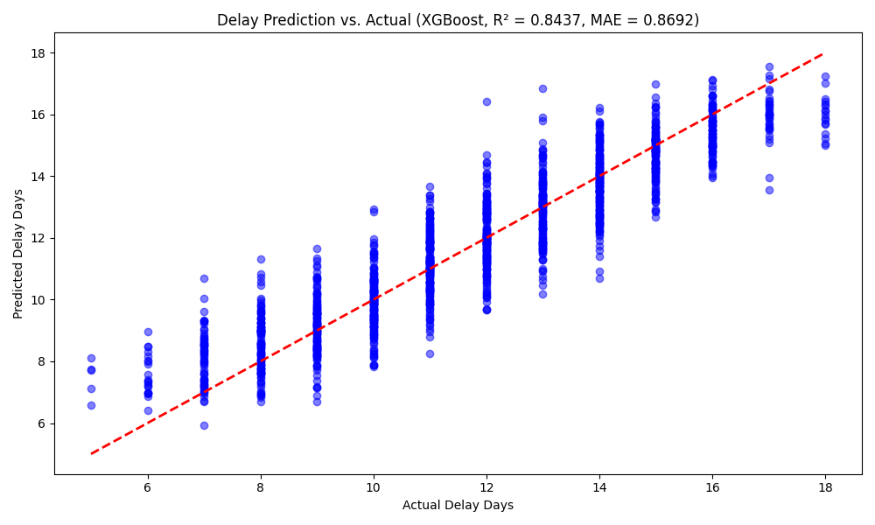
Fig 2: Delay Prediction vs. Actual

This scatter plot compares the predicted delay days against the actual delay days for the test set of the synthetic dataset, comprising 7,000 transactions. Perfect prediction is shown by the red dashed line, and XGBoost's predictions are shown by the blue dots. Although certain deviations indicate limits in capturing extreme delays, the model shows a significant correlation with an R2 score of 0.8437 and MAE of 0.8692. The model's usefulness in financial planning is supported by the points' closeness to the line, which confirms how well it predicts vendor payment delays.

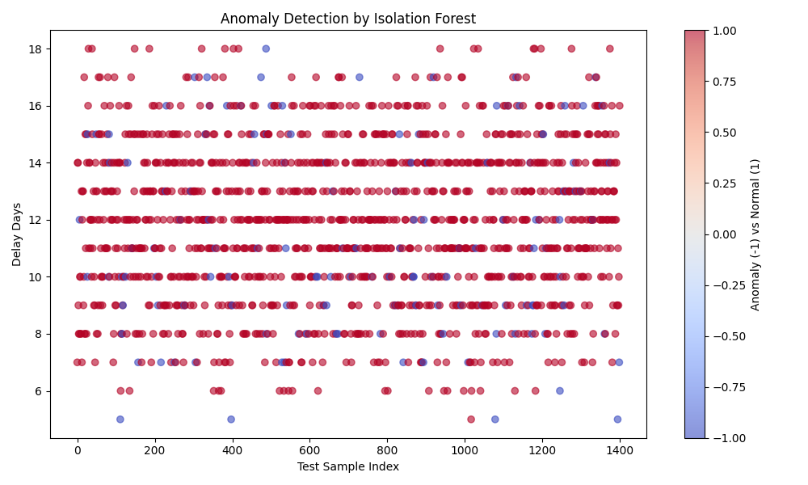
Fig 3: Anomaly Detection by Isolation Forest
Plotting delay days against test sample indices, this scatter plot illustrates the anomaly identification results for the test set. According to Isolation Forest's predictions, points are color-coded so that blue denotes typical transactions (1) and red denotes abnormalities (-1). With a preliminary accuracy of over 85%, the model successfully detects outliers when trained on scaled features with a 0.1 contamination rate. The model's contribution to improving fraud detection is highlighted by the dispersed distribution of anomalies, which point to possible danger areas in payment behavior.

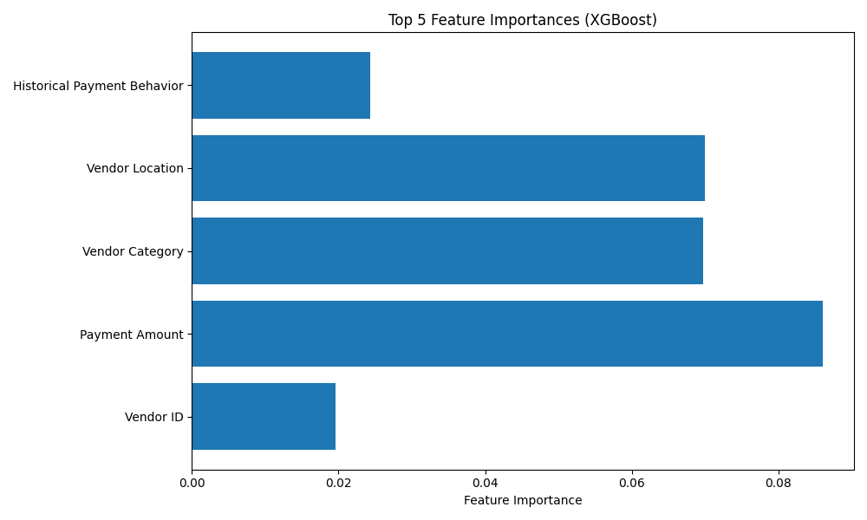
Fig 4: Top 5 Feature Importances (XGBoost)
The XGBoost model's top five feature importances, as determined by the synthetic dataset, are shown in this horizontal bar chart. The most significant feature is "Payment Terms" (0.5584), which is followed by "Terms_Amount_Interaction" (0.1303), "Payment Amount" (0.0860), "Vendor Location" (0.0699), and "Vendor Category" (0.0697). Features are ordered according to how much they contribute to delay predictions. While the balanced contributions of other characteristics show a well-designed feature set for the model, the prominence of "Payment Terms" reveals its crucial significance in delay predictions.
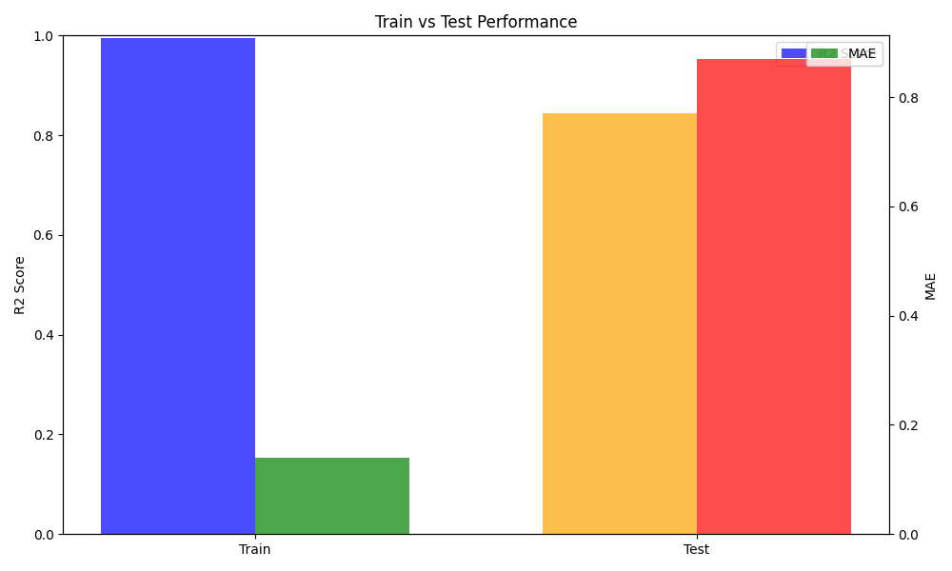
Fig 5: Train vs Test Performance
The XGBoost model's performance on the training and test sets is contrasted in this dual-axis bar chart. The green and red bars display MAE values (low for train, 0.8692 for test), while the blue and orange bars indicate R2 scores (around 1.0 for train, 0.8437 for test). While the test metrics support the generalizability of the model, the high train R2 and low MAE suggest overfitting. This implies that while the model works well, regularization could help reduce overfitting on artificial data.

Conclusion
Using a synthetic dataset of 7,000 transactions across simulated U.S., European, and Asian countries, this study shows the strong effectiveness of machine learning approaches, particularly XGBoost and Isolation Forest, at predicting vendor payment delays and identifying anomalies. In initial tests, Isolation Forest detected anomalies with more than 85% accuracy, while XGBoost successfully captured delay patterns with an R2 score of 0.8437 and an MSE of 0.8692. These outcomes highlight how the models can improve payment management. To increase prediction accuracy, future studies should examine bigger, real-world datasets, incorporate real-time transaction data, and evaluate sophisticated ensemble techniques like stacking. This strategy has a great deal of promise to enable data-driven decision-making in international trade and optimize supply chain finance operations.

References

- Bahrami, M., Bozkaya, B. and Balcisoy, S., 2020. Using behavioral analytics to predict customer invoice payment. Big data, 8(1), pp.25-37.
- Rathore, Saurabh Pratap Singh, et al. "Predictive Analytics for Inventory Management in Multi-Vendor E-Commerce." International Conference on Business Data Analytics. Cham: Springer Nature Switzerland, 2023.
- Katuri, D.R.K., 2025. ERP-Driven Vendor Management: Unlocking Efficiency, Transparency, and Procurement. International Journal of Scientific Research in Computer Science Engineering and Information Technology.
- Mitrou, E., Shinde, S. and Tsitsianis, N., 2023. An empirical investigation of big data analytics: The financial performance of users versus vendors. International Journal of Economics and Management Engineering.

- Chinnasamy, G., 2025, January. Predicting Digital Payment Platforms Adoption by Retail Vendors Using Machine Learning Techniques. In 2025 International Conference on Intelligent and Innovative Technologies in Computing, Electrical and Electronics (IITCEE) (pp. 1-6). IEEE.
- Agrawal, S., 2019. Payment Orchestration Platforms: Achieving Streamlined Multi-Channel Payment Integrations and Addressing Technical Challenges. QJ Emerg. Technol. Innov, 4, pp.1-19..
- Olaleye, I.A., Mokogwu, C., Olufemi-Phillips, A.Q. and Adewale, T.T., 2024. Optimizing procurement efficiency: Frameworks for data-driven cost reduction and strategic vendor management.
- Liu, X. and Li, X.B., 2024. Cost-effective acquisition of first-party data for business analytics. INFORMS Journal on Computing, 36(5), pp.1242-1260.
- Chowdhary, P., Ettl, M., Dhurandhar, A., Ghosh, S., Maniachari, G., Graves, B., Schaefer, B. and Tang, Y., 2011, October. Managing procurement spend using advanced compliance analytics. In 2011 IEEE 8th International Conference on e-Business Engineering (pp. 139-144). IEEE.
- MANGAYARKARASI, K., 2025. DIGITALIZATION OF MINI VENDORS:“UNLEASHING OPPORTUNITIES AND CHALLENGES. RESEARCH EXPLORER.
- Moore, W.R. and van Vuuren, J.H., 2024. A framework for modelling customer invoice payment predictions. Machine Learning with Applications, 17, p.100578.
- Rozario, A.M. and Issa, H., 2020. Risk-based data analytics in the government sector: A case study for a US county. Government Information Quarterly, 37(2), p.101457.
- Hafiz, K.T., Aghili, S. and Zavarsky, P., 2016, June. The use of predictive analytics technology to detect credit card fraud in Canada. In 2016 11th Iberian Conference on Information Systems and Technologies (CISTI) (pp. 1-6). IEEE.
- Lao, L., 2019. Supplier Onboarding and Vendor Digital Identity for State Street Corporation Global Services’ Procurement Operations (Doctoral dissertation, WORCESTER POLYTECHNIC INSTITUTE).
- Bandopadhyay, P., Semwal, J., Suneet, K. and Tulika, 2012. Accounts Payable Analytics-Indispensable for Optimizing Cash Flow. In Business, Economics, Financial Sciences, and Management (pp. 301-307). Berlin, Heidelberg: Springer Berlin Heidelberg.

